Oviya Srinivasan

1. How many total combinations are possible? Show the math along with the code!

  
The total number of combinations possible when rolling two six-sided dice can be calculated by multiplying the number of outcomes for each die. Since each die has 6 faces, the total number of combinations is 6∗6=36

2. Calculate and display the distribution of all possible combinations that can be

obtained when rolling both Die A and Die B together. Show the math along with

the code!

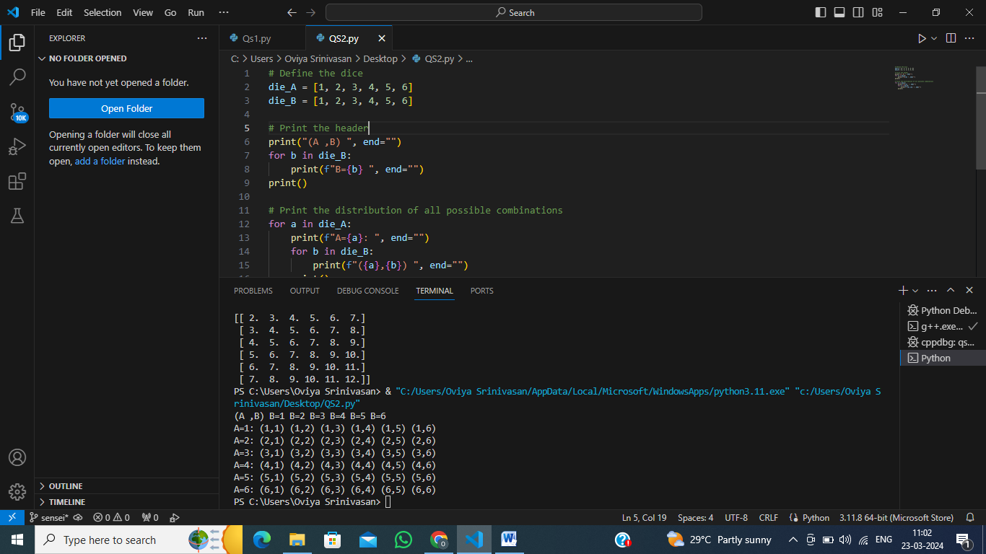Hint: A 6 x 6 Matrix.

The distribution of all possible combinations when rolling two six-sided dice can be represented as a 6x6 matrix, where each cell (i, j) represents the sum of the outcomes when Die A shows i and Die B shows j.

3. Calculate the Probability of all Possible Sums occurring among the number of

combinations from (2).

When two dice are rolled, the smallest possible sum is 2 (both dice show 1) and the largest possible sum is 12 (both dice show 6). The total number of outcomes when two dice are rolled is 6×6=36 because each die has 6 faces.

The number of outcomes where the sum of the dice is 2 is only 1 (Die A = 1, Die B = 1). So, the probability of getting a sum of 2 is 361​.

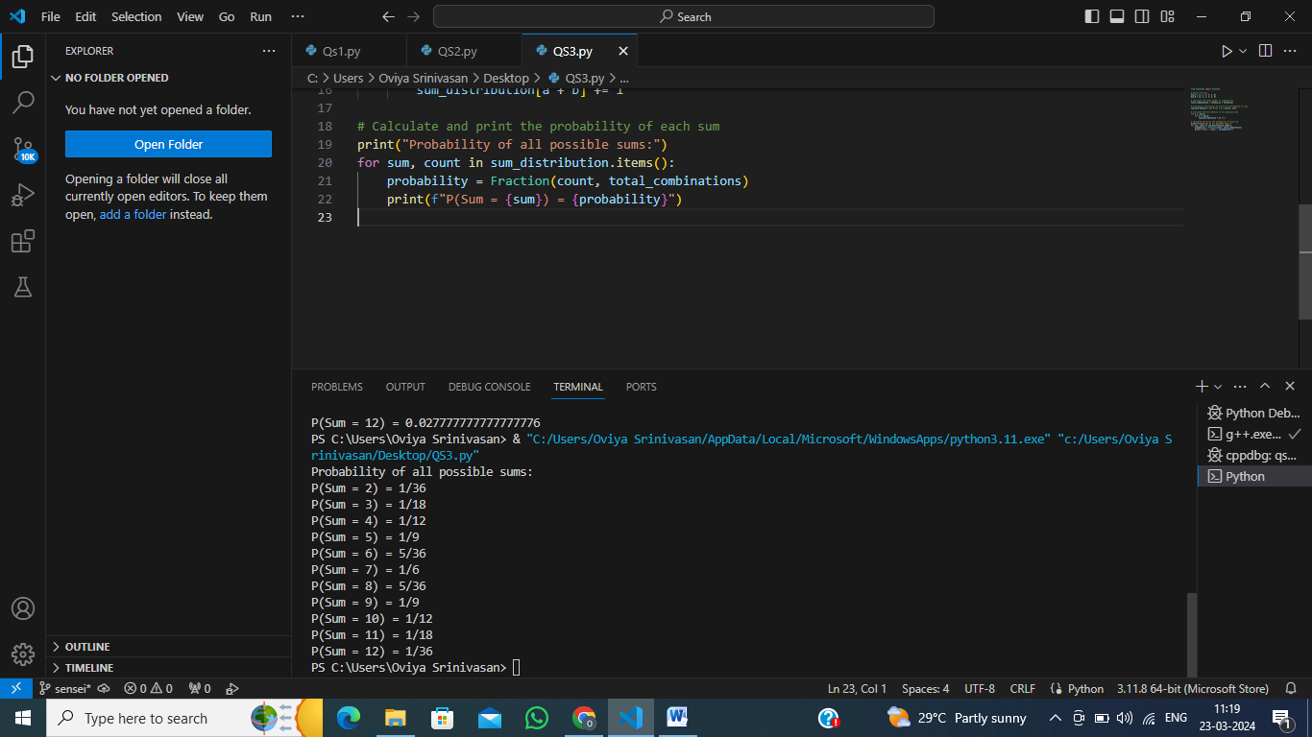

Part B:

We are considering two dice. The first die has faces numbered from 1 to 4, and the second die has faces numbered from 1 to 8. We are interested in all possible sums that can be obtained by rolling these two dice. The highest sum that can be obtained is 12 (4 from the first die and 8 from the second die).

We then calculate all possible combinations that can result in each sum, from 2 to 12. These combinations represent the different ways the faces of the two dice can add up to a particular sum.

Next, we calculate the probability of each sum occurring. This is done by dividing the number of combinations that result in that sum by the total number of possible outcomes (which is 4 times 8, or 32, in this case).

Finally, we compare these calculated probabilities with the ideal probabilities. If they match, we can say that the combination of faces on the two dice is perfect. In other words, the distribution of sums from rolling these two dice matches the ideal distribution.

